EXPERIMENT 06

Consider Brazilian E-Commerce Dataset by Olist and perform the following
Load 3 different datasets from Olist Kaggle to tableau by launching the Tableau Desktop and upload all the dataset using text file as option and merge all the datasets to form a single merged dataset so that analysis can be done easily.
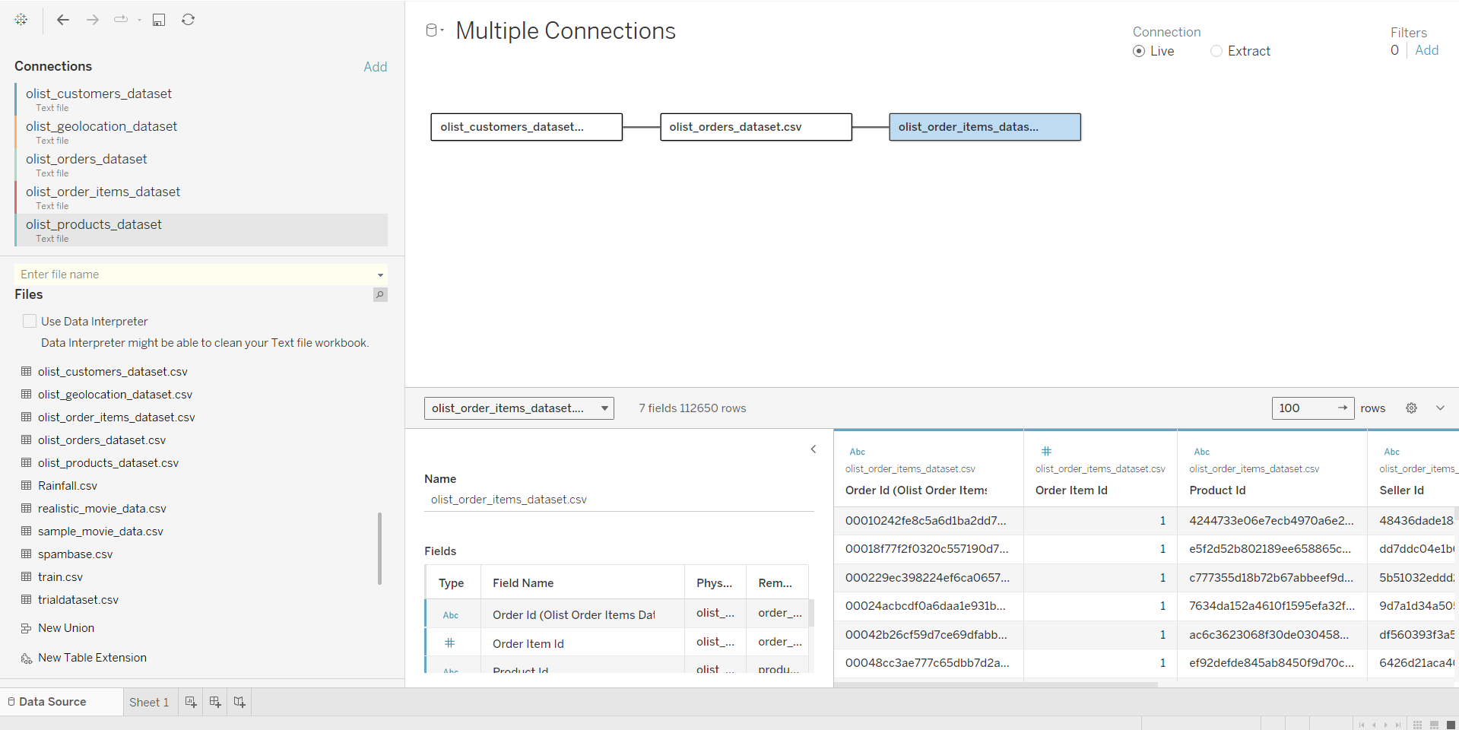
- Perform calculations:
- Calculate the Total Delivered Orders
To calculate the total number of delivered orders, use the following formula in Tableau: SUM(IIF([order_status] = 'delivered', 1, 0)) / COUNT([order_id])
This formula checks each order’s status. If it's 'delivered', it assigns a value of 1, otherwise 0. The sum of these values gives the total delivered orders. Dividing by the total number of orders (COUNT([order_id])) provides the proportion of delivered orders.
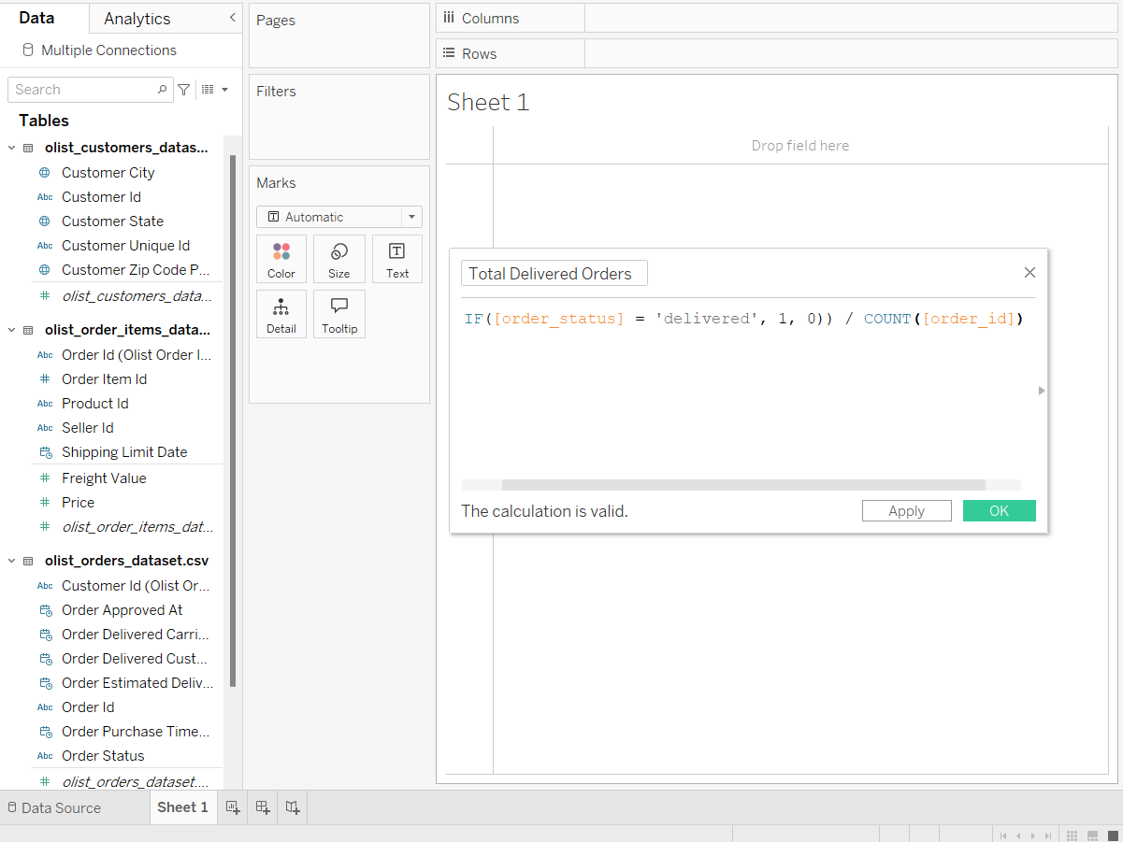

- Calculate the Average Product Price
Drag the price field to the Rows shelf in Tableau, then change its aggregation to AVG. This will give you the average price per product across all orders.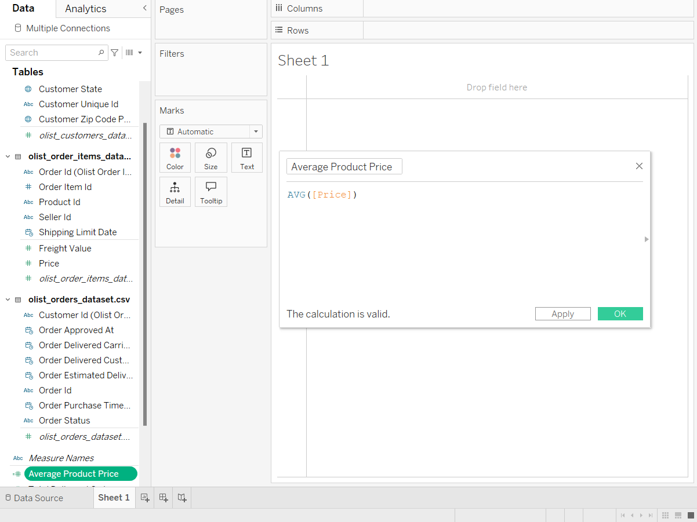

- Calculate the Total Freight Value
Drag the freight_value field to the Rows shelf and change the aggregation to SUM. This will provide the total freight costs for all orders in the dataset.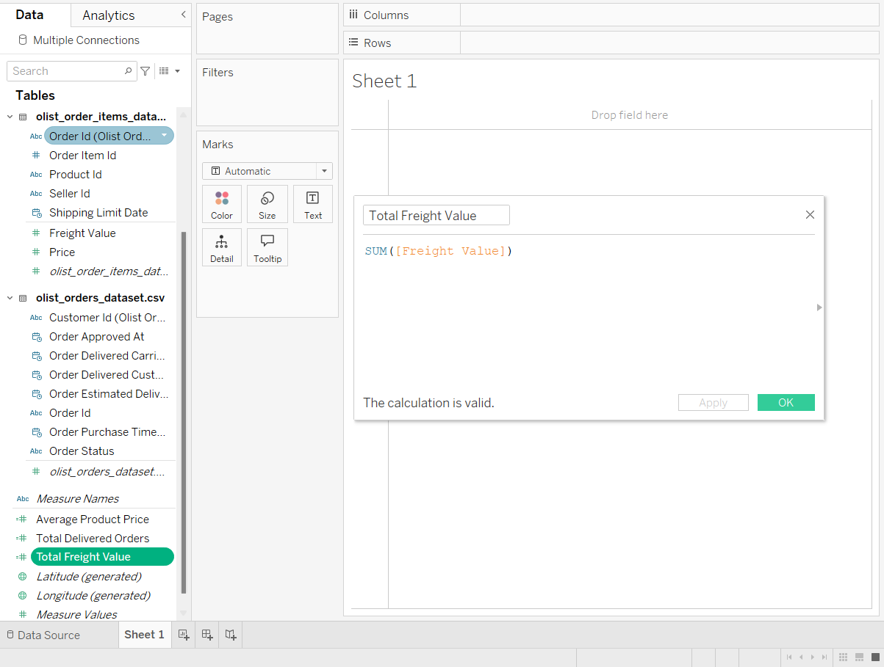

- Perform group operations
- Create a Group Customers by Order Count
Create a calculated field to categorize customers based on the number of orders they've placed. Group customers into categories for easy segmentation and analysis.
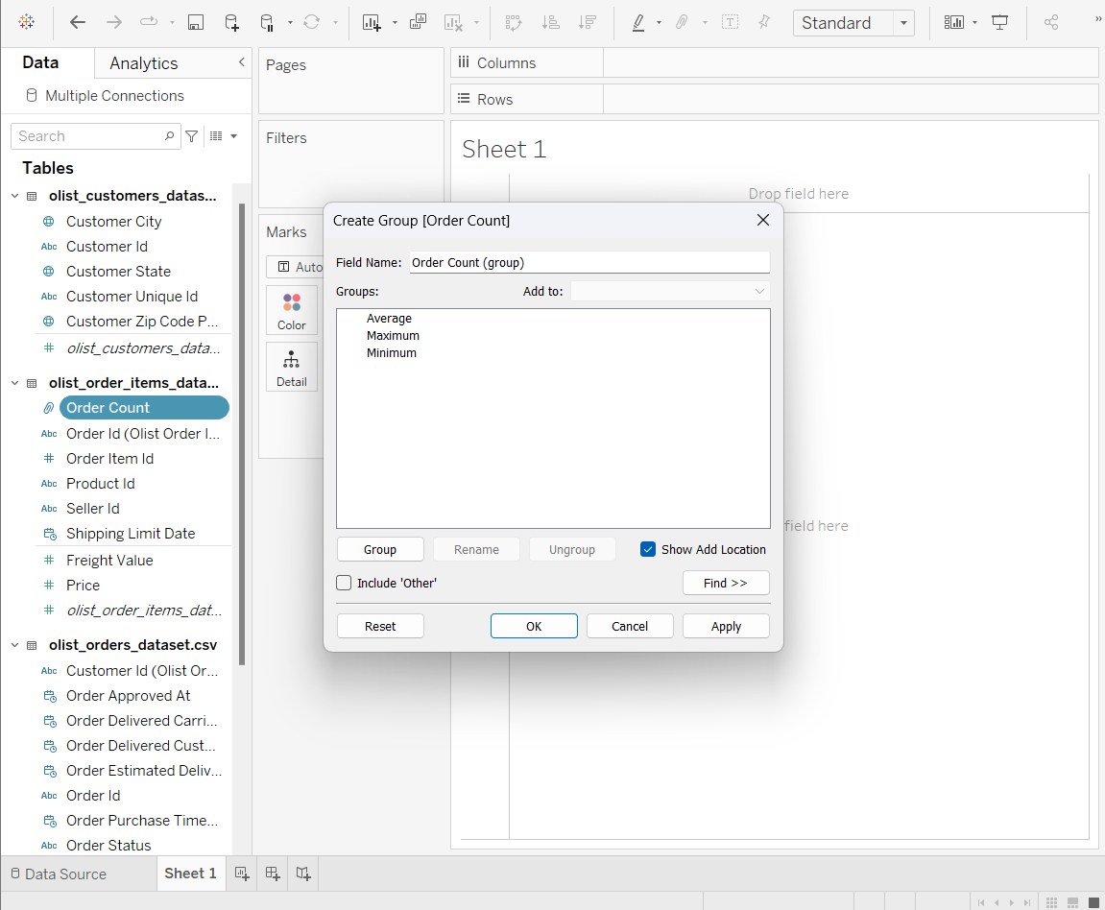

- Create a Group by Delivery Status
Create a group based on the order_status field to categorize orders into 'delivered', 'pending', 'canceled', etc. This helps in understanding the distribution of orders by status.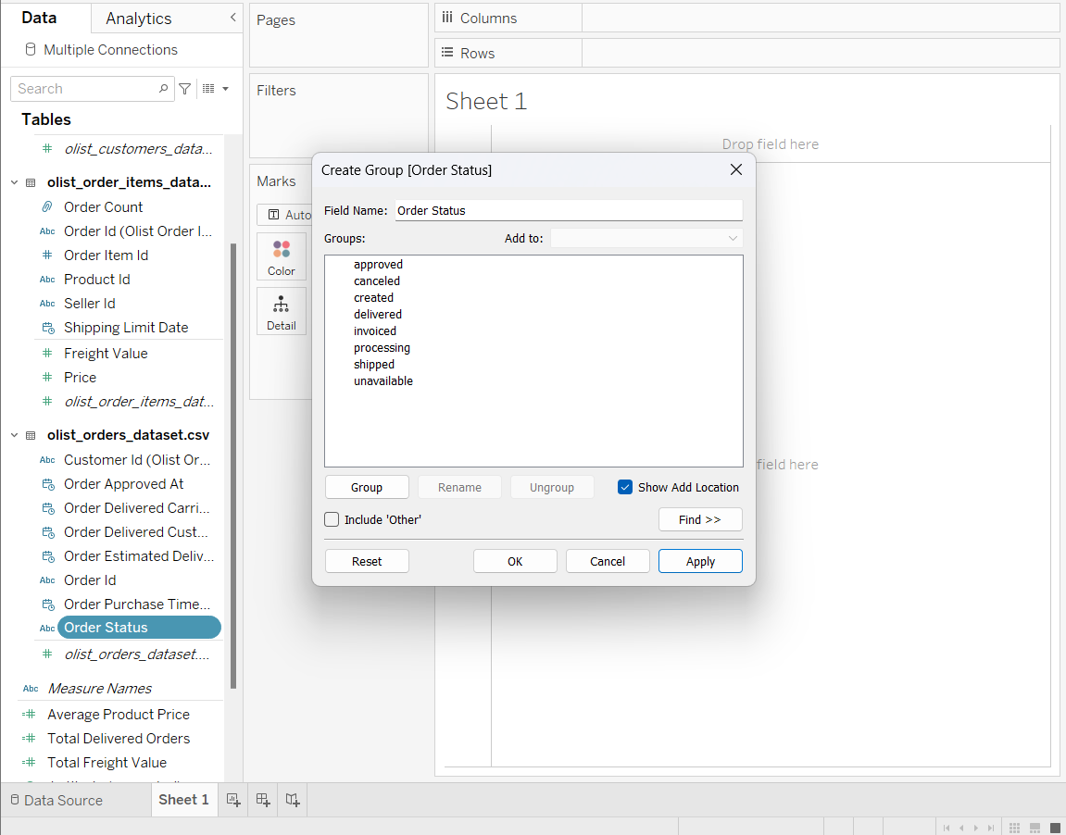
- Create a Set for On-Time Delivery
Create a set to include only orders where order_delivered_customer_date <= order_estimated_delivery_date.
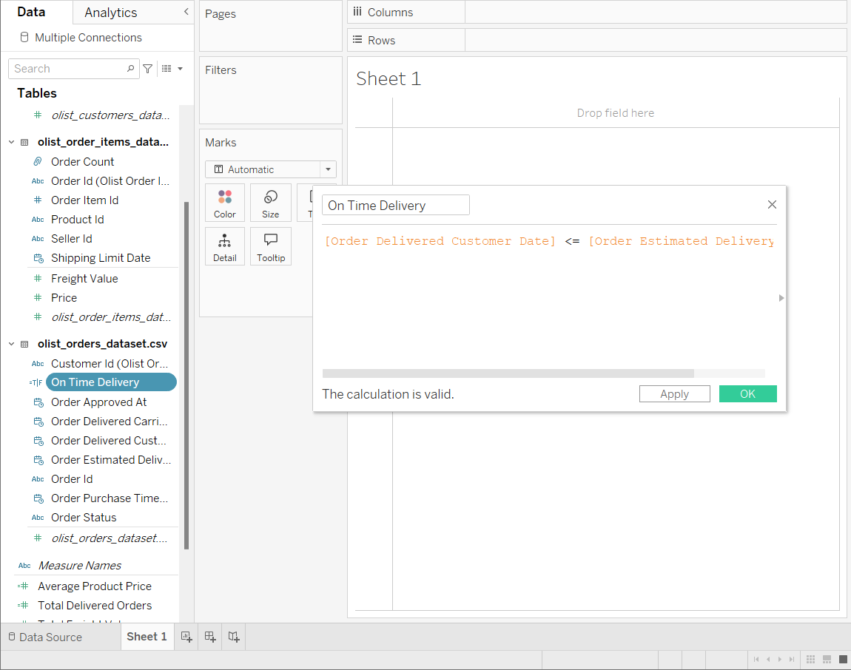

- Create dashboard
- Orders by State - Bar Chart
Drag customer_state to the Columns shelf. Drag order_id to the Rows shelf and change its aggregation to COUNT. Apply filters to include only delivered orders.
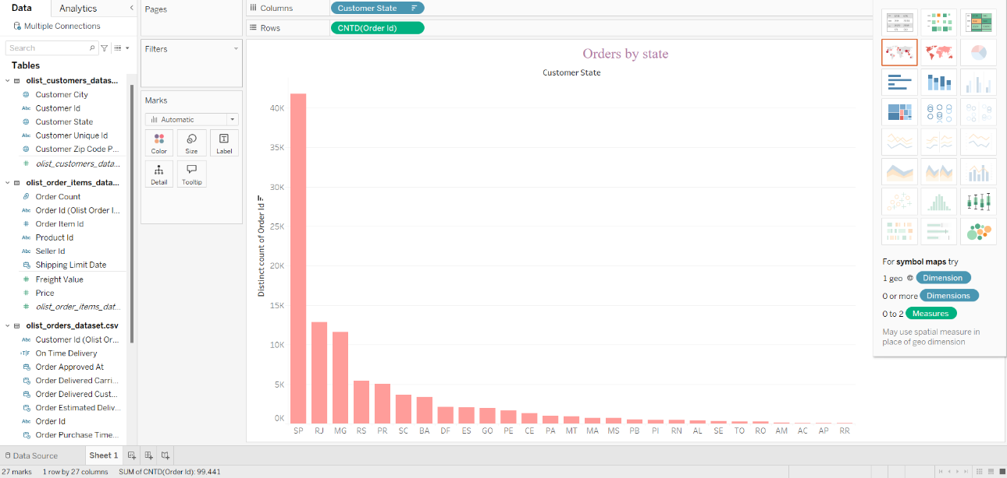

- Average Price by State
Drag customer_state to the Columns shelf. Drag price to the Rows shelf, then change its aggregation to AVG. Format the axis to display currency for clarity.
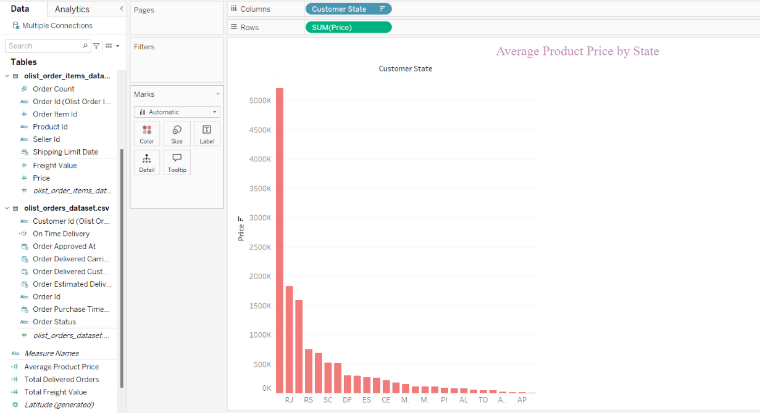
- Order Status Distribution
Drag order_status to the Columns shelf. Drag order_id to the Rows shelf, changing its aggregation to COUNT. Convert the chart type to Bar Chart. Customize colors and labels for better visual distinction.

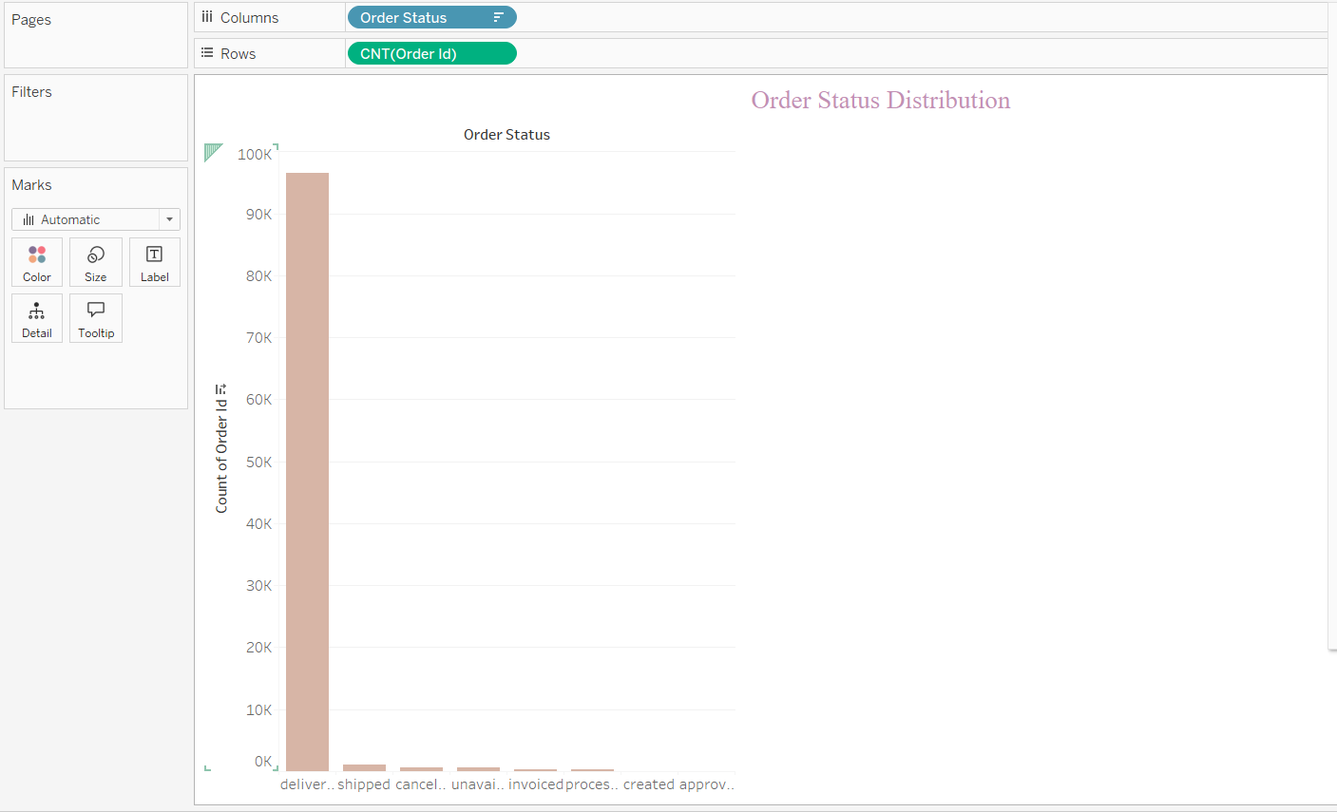

- Add additional visualizations
When designing additional visualizations, focus on clear and relevant chart types, such as histograms for distributions and bar charts for comparisons. Maintain consistent colours, fonts, and styles, using annotations and tooltips to highlight key insights like survival rates or fare trends. Add interactivity with filters and dropdowns to explore data dynamically, ensuring a balanced and intuitive layout. Group related charts logically, and include clear titles and legends to make the visuals self-explanatory and impactful.

- Combine dashboards.
Combine all visualizations into a single dashboard. Drag and drop each chart into the dashboard workspace, arranging them logically. Add interactivity by including filters for age groups, fare groups, and class to allow users to explore different aspects of the data. Ensure the layout is clear and visually appealing for effective storytelling.

